Logging in to Canvas as a Parent Observer

Go to:

https://kotarahs.instructure.com/login/canvas

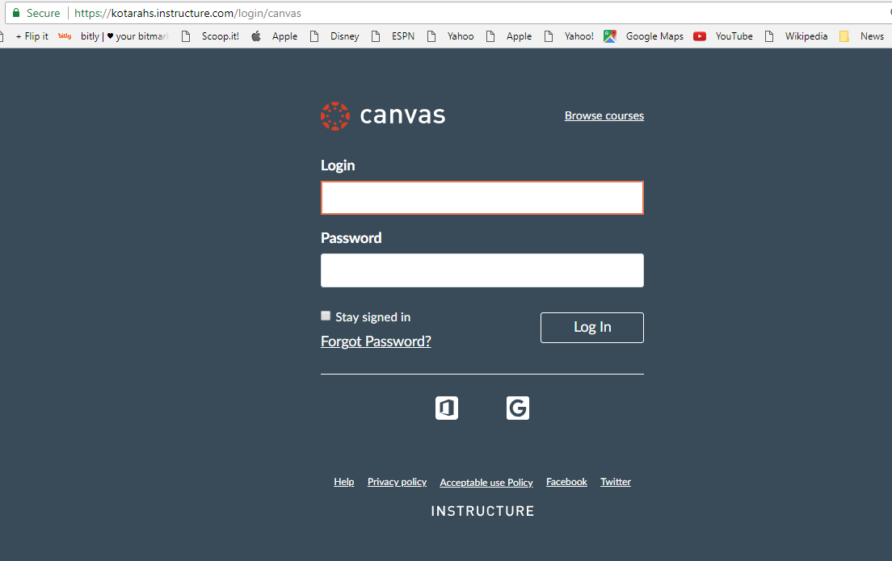

User ID: Your email used for the Parent portal
Password: Your child’s birthday in the following format –

DD_MM_YYYY

* Please include the underscores in your password

Note: If you have more than one child enrolled at Kotara High, your password will be the birthday of the last student to appear alphabetically e.g.

John Smith
Lisa Smith

The birthday of Lisa will be the password.

